The Arkansas Bar Association Announces New Logo and Governance Structure

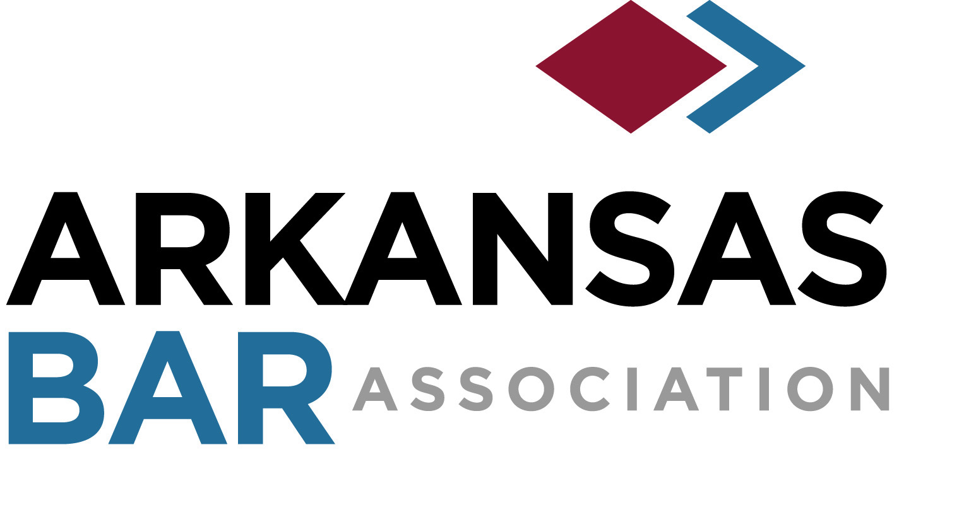

The Arkansas Bar Association (ArkBar) is excited to reveal its new logo that is being released in conjunction with its new governance structure. “As we transition and move the association forward, we believe the new logo reflects our dedicated and diverse membership,” said Karen K. Hutchins, Executive Director.

ArkBar is moving forward to meet future statewide expectations by rolling out its new governance structure. The new governance structure creates a single Board of Trustees consisting of 15 statewide districts. The new trustees were elected in May and began serving at the inaugural meeting of the Board of Trustees during the association’s virtual annual meeting in June.

“The new governance structure will allow the association to be more responsive, as the legal profession continues to meet the challenges that require quicker responses and increased technology in the practice of law,” Hutchins said.

The new logo was designed by Mangan Holcomb Partners.

Below is the list of members who have been elected to lead the association this year:

The 2020-2021 Officers:
President: Paul. W. Keith, Hamburg
President-Elect: Bob Estes, Fayetteville
Immediate Past President: Brian Rosenthal, Little Rock
Treasurer: Joseph F. Kolb, Little Rock
Secretary: Glen Hoggard, North Little Rock
Young Lawyers Section Chair: Chris Hussein, Fayetteville
Parliamentarian: Aaron Squyres, Little Rock

The Inaugural Board of Trustees:
Kelsey Kaylyn Bardwell, Harrison
Jordan Bates-Rogers, Little Rock
Kandice A. Bell, White Hall
Melanie Ann Beltran, Clinton
Maggie Benson, Fayetteville
Laurie A. Bridewell, Lake Village
Evelyn E. Brooks, Fayetteville
Randall L. Bynum, Little Rock
Thomas M. Carpenter, Little Rock
Sterling Taylor Chaney, Arkadelphia
Kesha Zaffino Chiappinelli, Bentonville
Brinkley Beecher Cook-Campbell, Fort Smith
Bryce Cook, Jonesboro
Craig L. Cook, Fort Smith
Laurie A. Bridewell, Lake Village
Leslie Copeland, Fayetteville
Tim J. Cullen, Little Rock
Carol C. Dalby, Texarkana
Joe Aaron Denton, Conway
Margaret Dobson, Sheridan
Bob Edwards, Little Rock
Paul Nathaniel Ford, Jonesboro
Amy Freedman, Texarkana
Caleb Peter Garcia, Little Rock
Jesse J. Gibson, Little Rock
Steven P. Harrelson, Little Rock
Michael McCarty Harrison, Little Rock
Jason M. Hatfield, Fayetteville
Geoff Hamby, Centerton
Christopher Heil, Little Rock
Jason B. Hendren, Rogers
Rachel Hildebrand, Little Rock
Brian C. Hogue, Fayetteville
Anton Leo Janik, Jr., Little Rock
Sarah Coppola Jewell, Fayetteville
Jamie Huffman Jones, Little Rock
Taylor Andrew King, Arkadelphia
Alan Lee Lane, Fayetteville
George A. Lea, Jr., Pine Bluff
Victoria Leigh, North Little Rock
Jessica Virden Mallett, Little Rock
Skye Martin, Little Rock
Stefan McBride, North Little Rock
Kathleen M. McDonald, Little Rock
J. Cliff McKinney II, Little Rock
Jeremy M. McNabb, Little Rock
Mary Catherine McNulty, Little Rock
David Stockley Mitchell, Jr., Little Rock
Meredith Strong Moore, Little Rock
John Ogles, Jacksonville
Brant Perkins, Jonesboro
John Rainwater, Little Rock
George M. Rozzell, Rogers
Ryan Scott, Rogers
Dusti Standridge, Fort Smith
Carter C. Stein, Little Rock
Paul D. Waddell, Jonesboro
Todd Cooper Watson, Newport
William Zac White, Heber Springs
Patrick D. Wilson, Little Rock
George R. Wise, Little Rock

About Arkansas Bar Association
Founded in 1898, the Arkansas Bar Association is the premier legal association in the state. As a voluntary organization of more than 5,300 members, the Association’s primary mission is to support attorneys; advance the practice of law; advocate for the legal profession; foster professionalism, civility, and integrity; and protect the rule of law.

