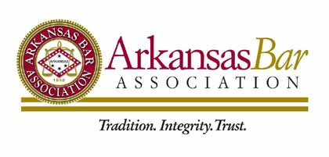
FOR IMMEDIATE RELEASE
March 6, 2017
MEDIA CONTACT:
Anna Hubbard
Arkansas Bar Association
Office: (501) 375-4606
cnewton@arkbar.com

ARKANSAS BAR ASSOCIATION HOSTS MOCK TRIAL COMPETITION

LITTLE ROCK, Ark. (March 6, 2017) – For the second consecutive year, students from the Springdale Har-Ber High School in Springdale, AR prevailed as the winners of the Arkansas Mock Trial Competition. Over 200 high school students from across the state gathered in Little Rock on March 3-4, 2017 for the event, with 29 teams competing.

The Springdale Har-Ber High School Carolina team won the final match over the Springdale Har-Ber High School Navy team. The team will represent Arkansas at the National High School Mock Trial Championship in Hartford, CT May 11-13, 2017.

The semi-finals rounds included the top four teams: Parkview Arts/Science Magnet High School, Springdale Har-Ber High School Carolina Team, Springdale Har-Ber High School Navy Team and Mount St. Mary Academy and Catholic High School Junior Team.

This year’s competition was held the US Federal Courthouse and the Pulaski County Courthouse in Little Rock starting on Friday afternoon and concluding on Saturday evening. The final round of competition was held at the US Federal Courthouse with Honorable Mary Spencer McGowan presiding, and the Arkansas Bar Association President Denise Reid Hoggard and Arkansas Bar Foundation Past President Frank B. Sewall serving as scoring judges.

This year’s Mock Trial case was a civil case involving an accident between the driver of a vehicle and a bicyclist.

Special thanks to the ArkBar Mock Trial Committee, Arkansas Bar Association, Arkansas Bar Foundation, and the Arkansas Bar Association’s annual sponsors.

Parents and teachers who are interested in bringing the Mock Trial program to their school are encouraged to contact the Arkansas Bar Association. The ArkBar can provide curriculum plans for in-school classes as well as material for establishing a Mock Trial team as an extra-curricular activity. Only six students and a teacher-sponsor are needed for a team.

For more information on the Arkansas High School Mock Trial Competition, follow us on Twitter @ArkBarMT.

###

